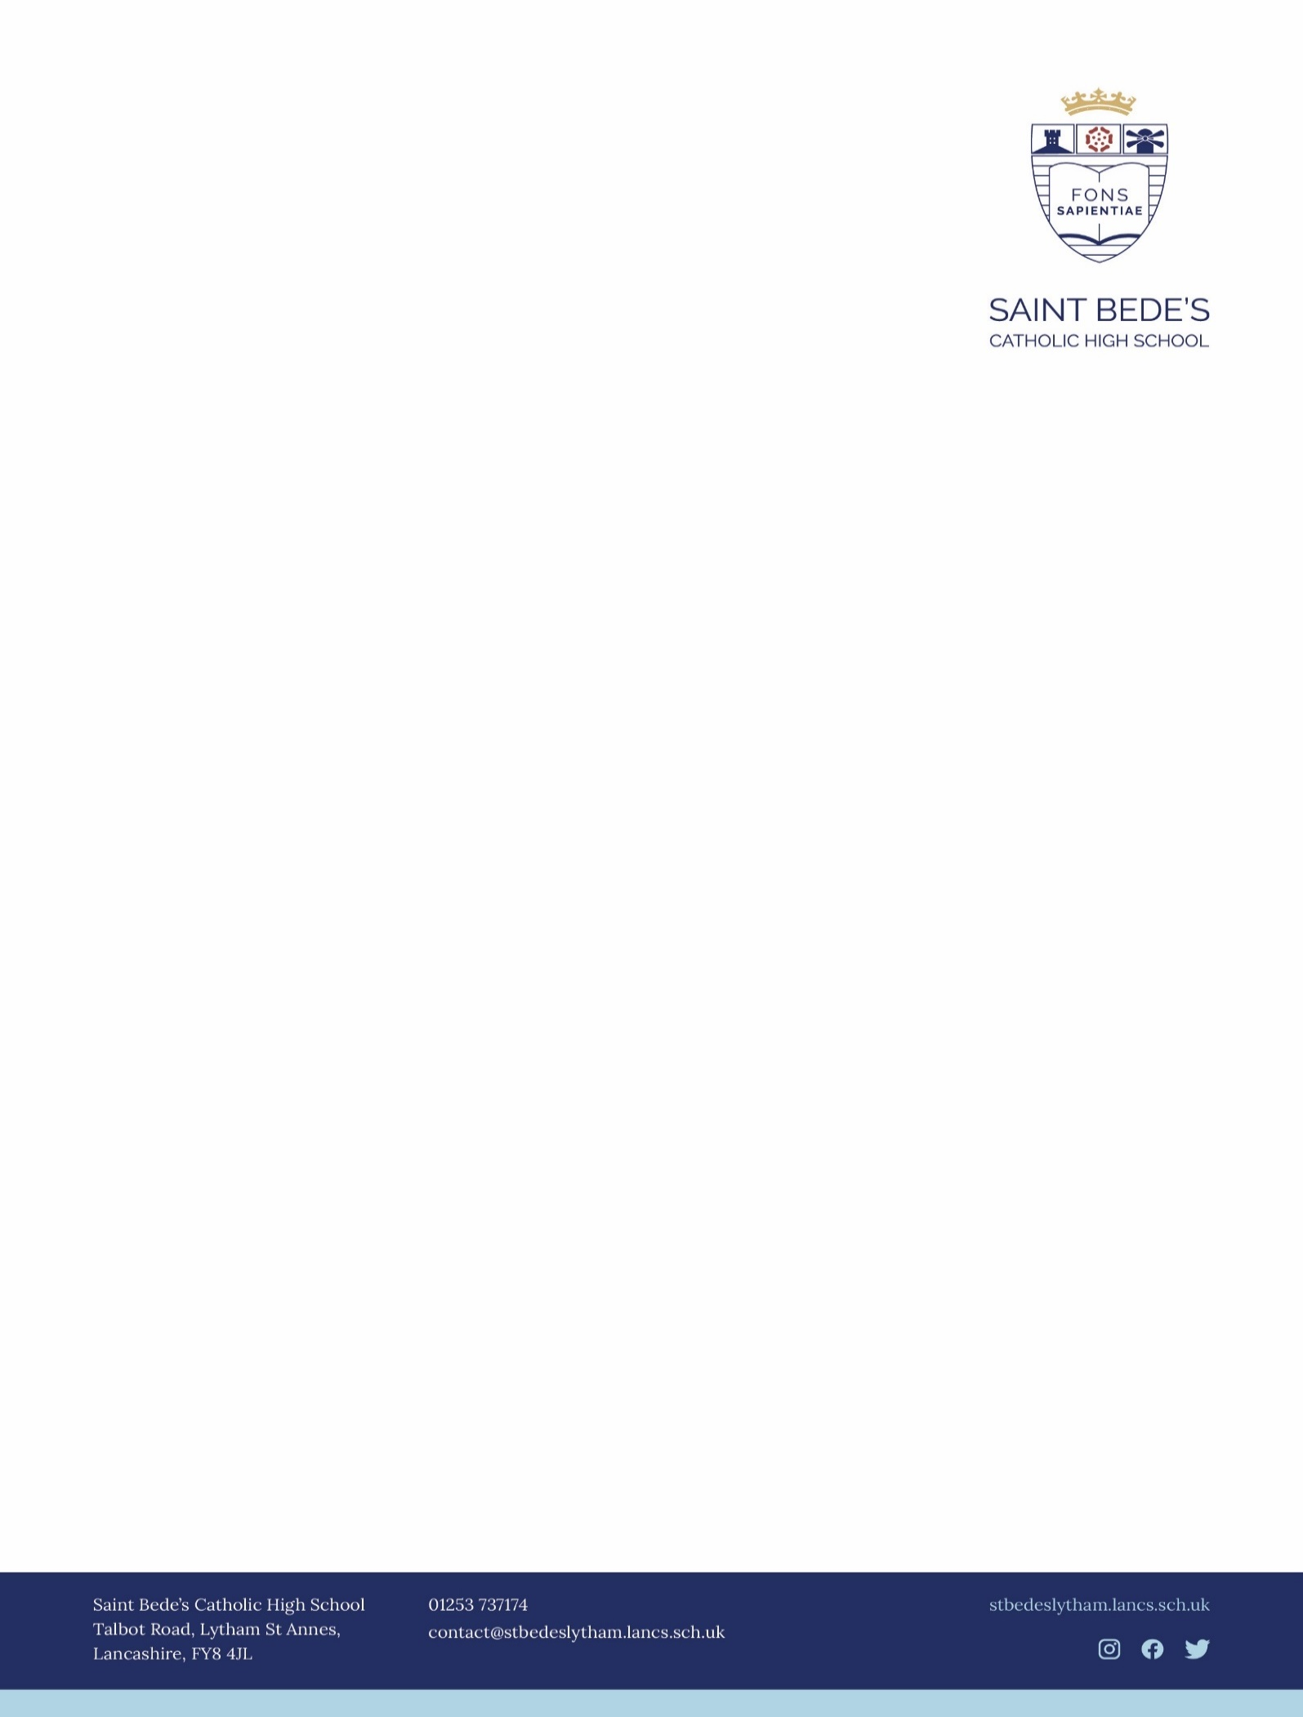

SAINT BEDE’S CATHOLIC HIGH SCHOOL SUPPLEMENTARY INFORMATION FORM
APPLICATION TO THE GOVERNORS OF SAINT BEDE’S FOR ADMISSION IN SEPTEMBER 2024
If you are applying for a place for your child in Saint Bede’s Catholic High School on faith grounds please complete this form in addition to the Common Application Form available online or issued by the Local Authority.
This supplementary information form will assist the Governors of the school in deciding whether your child qualifies for a place. Failure to complete the form may affect where your child is placed within the selection criteria.
Important : This Supplementary Information Form is NOT an Application Form but MUST be completed and returned to Saint Bede’s by 31st October 2023. Please ensure that you ALSO complete the online Admission to Secondary Schools common Application form issued by your local authority by 31st October 2023
Once the supplementary information form has been received and processed by School, you will receive an email confirming this. Should you not receive an email confirmation 10 days after submitting, please contact School.

A) FOR PUPILS RESIDENT IN THE AREA ADMINISTERED BY LANCASHIRE COUNTY COUNCIL

A) FOR PUPILS RESIDENT IN THE AREA ADMINISTERED BY LANCASHIRE COUNTY COUNCIL
A paper copy may be obtained from the Area Education Office (Telephone: 01524 – 581148) for those who do not have internet access. This should be returned to your child’s primary school.
B) FOR PUPILS RESIDENT IN THE AREA ADMINISTERED BY BLACKPOOL BOROUGH COUNCIL
A paper copy may be obtained from Blackpool Education Office (01253 476829) for those who do not have internet access. This should be returned to your child’s primary school.

PART A (To be completed by child/applicant’s parent or carer)

A1 Child’s Full Name: __________________________________________________________________________

A2 Date of Birth: __________________________________ Male/Female: ________________________________

A3 Address: _________________________________________________________________________________

____________________Post Code: _______________ Telephone Number: ___________________

A4 Present School: ___________________________________________________________________________

A5 Full Names of Parents/Carer:

1. _________________________________________________________________________________________

2. _________________________________________________________________________________________

If you are applying on faith grounds, please complete the following sections:

A6 Parish or area of faith community in which you live ________________________________________________
(e.g. St Peter’s, Lytham)

A7 Name of Parish or area of faith community in which you worship, if different from above
(Your parish Priest or minister of religion may be contacted to confirm this)

_________________________________________________________________________________________

A8 Name(s) of any sibling(s) who will be attending Saint Bede’s at time of the applicant’s planned admission in September 2023

Names: ____________________________________ Date of Birth: ____________________ Current Year:_______

____________________________________ Date of Birth: ___________________ Current Year:_______

A9 If a Catholic, I confirm that the child/applicant is a Baptised Roman Catholic and enclose proof of baptism e.g. copy of Baptismal Certificate or details of place and date of baptism or letter from a priest confirming child’s/applicant’s preparation for Catholic baptism or faith membership.
Yes No

Parish : _________________ Town/City: _______________________ Date of Baptism: ______________

You are asked to enclose a copy of the Baptismal Certificate with this form. If this is not possible, explain below:

_________________________________________________________________________________________

_________________________________________________________________________________________

A10 If from another Christian denomination, I confirm that the child / applicant is baptised and enclose proof of baptism e.g. copy of Baptismal Certificate or confirmation in writing that the child/applicant is a member of their Faith community from an appropriate Minister of Religion.
Yes No

ADMISSIONS CRITERIA

Governors will admit pupils in accordance with the stated Admissions Policy. Please tick below to indicate the category which applies to your child. Please provide any relevant supporting evidence at the time of application.

1 | Baptised Roman Catholic Looked After Children and previously Looked After Children.
2 | Baptised Roman Catholic children who have a sibling in the school at the time of admission.
3 | Baptised Roman Catholic children from the following Roman Catholic Partner Primary Schools.  (St Peter’s Lytham, Our Lady, Star of the Sea, St Anne’s, The Willows, Kirkham, The Holy Family, Freckleton and Warton, St Joseph’s, Wesham).
4 | Other Baptised Roman Catholic children.
5 | Other Looked After Children and previously Looked After Children.
6 | Other children who have a sibling in the school at the time of admission.
7 | Other children from the Roman Catholic Partner Primary Schools instanced above.
8 | Children of staff employed at Saint Bede’s Catholic High School for two or more years or who have been recruited to meet a particular skills shortage.
9 | Baptised children from other Christian denominations.
10 | Other children.
Declaration: | IecI I the parent/carer of the above named child, confirm that to the best of my knowledge, the the iinformation given on this form is correct. If offered a place I agree to accept and abide  bbb by the school’s published codes of behaviour and uniform.

Signature: ________________________________________ (Parent/Carer) Date: _________________________

Parent/Carer Email: _________________________________________________________________________________

